Accessing a Web Server in a VPC – Documentation
Introduction
In this document, I have demonstrated the step-by-step process of configuring and accessing a web server within a Virtual Private Cloud (VPC). The setup includes creating networking components, launching an EC2 instance, and enabling secure access via the internet.

VPC Architecture Overview
In this step, I designed the overall VPC architecture. The VPC contains both public and private subnets to logically separate resources. I ensured that the public subnet is used for internet-facing components like the web server, while private subnets can be used for backend services if required. An Internet Gateway is attached to allow communication between the VPC and the external internet.
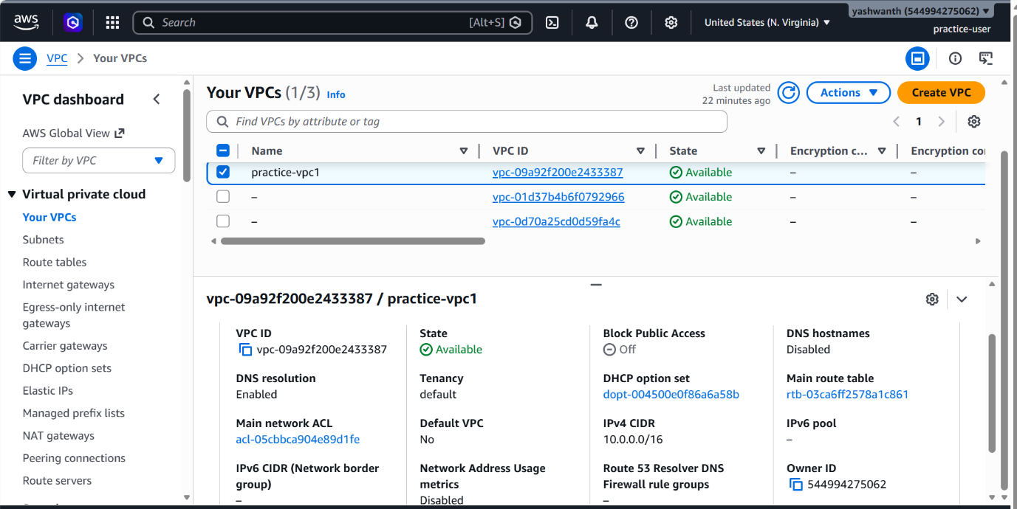

Subnet Configuration
I created subnets within the VPC to organize resources effectively. Specifically, I configured a public subnet that allows resources deployed within it to communicate with the internet. This subnet plays a key role in hosting the web server.
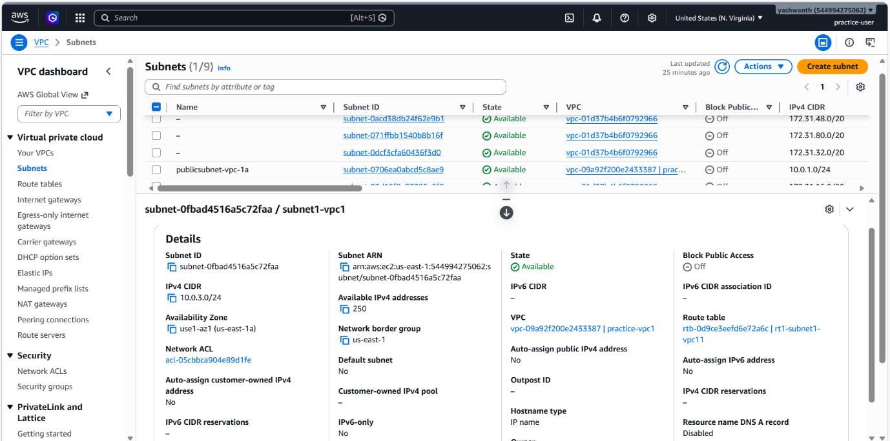

Route Table Setup
To enable internet connectivity, I configured the route table associated with the public subnet. I added a route (0.0.0.0/0) pointing to the Internet Gateway. This ensures that all outbound traffic from the subnet can reach external networks.
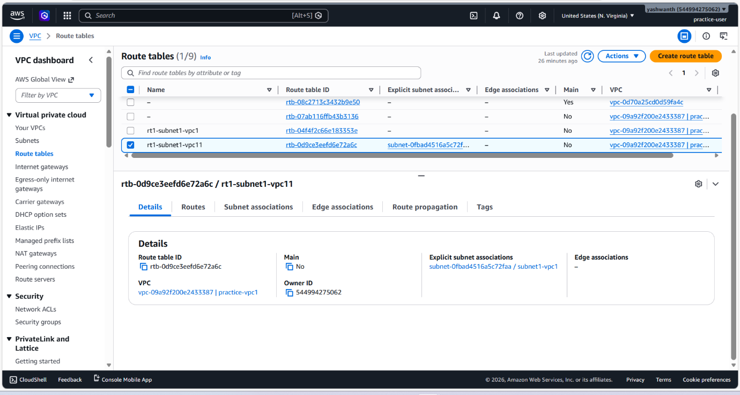

Internet Gateway Attachment
In this step, I attached an Internet Gateway to the VPC. This component acts as a bridge between the VPC and the internet. Without this, the resources in the VPC would not be accessible externally.
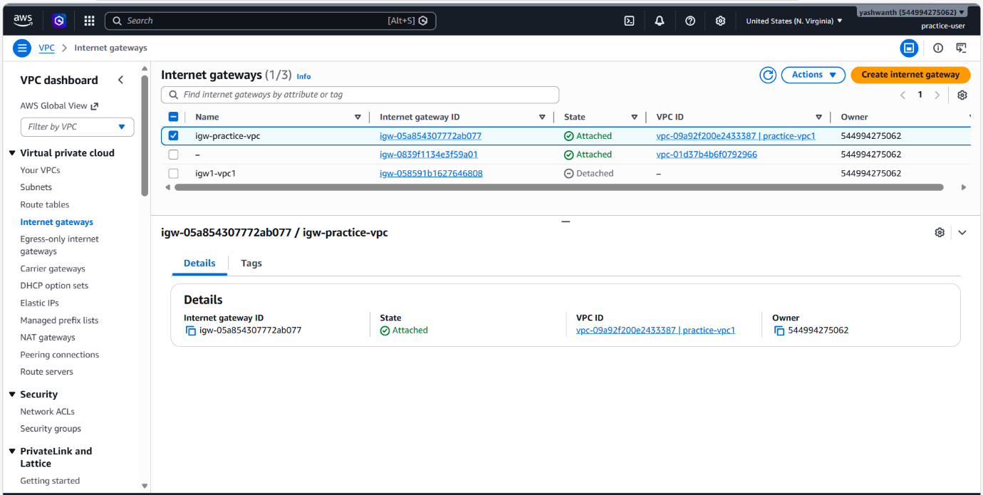

EC2 Instance Launch
I launched an EC2 instance within the public subnet to act as the web server. While configuring the instance, I ensured that it was assigned a public IP address so that it could be accessed from outside the VPC.
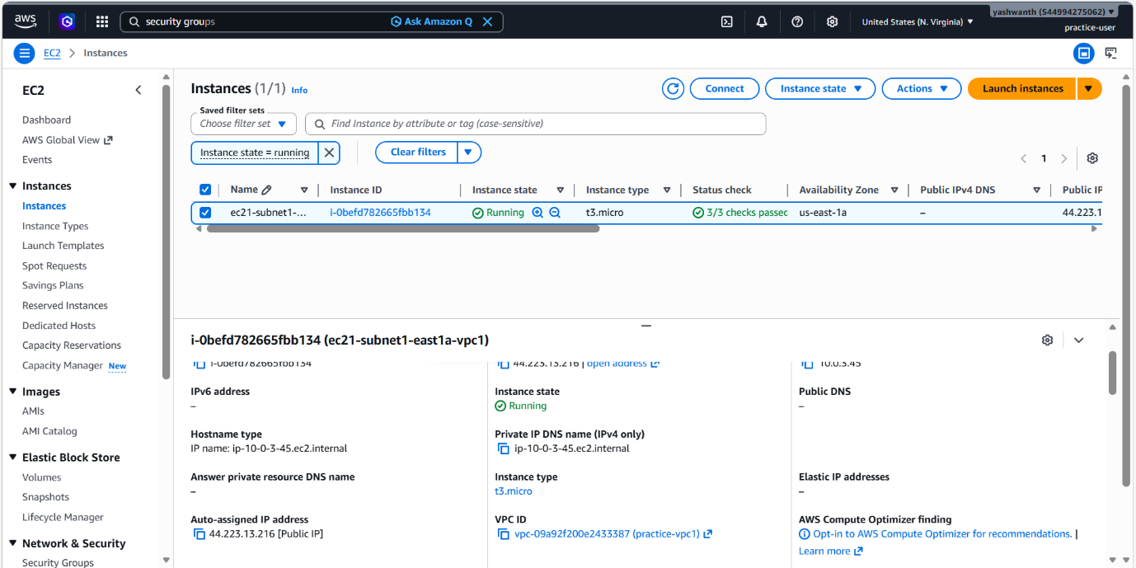

Security Group Configuration
To control access to the EC2 instance, I configured the security group. I allowed inbound traffic on port 80 (HTTP) and optionally port 443 (HTTPS). This ensures that users can access the web application securely through a browser.
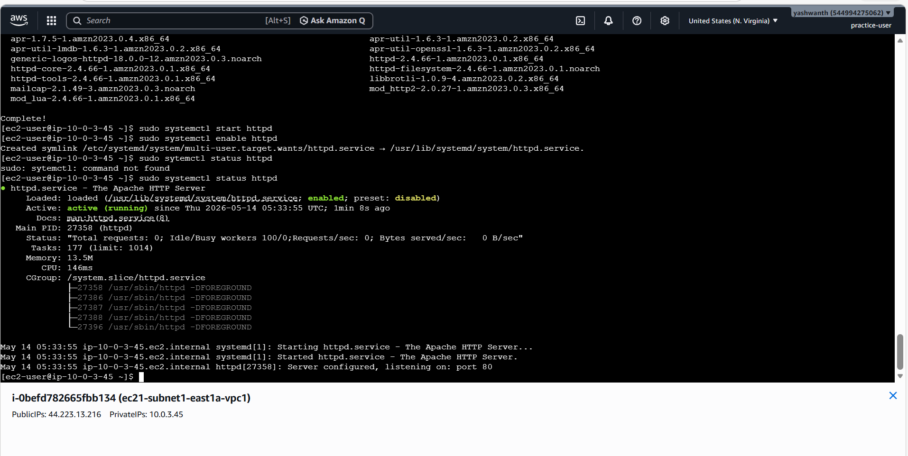

Accessing the Web Server
Finally, I verified the setup by accessing the web server using the public IP address of the EC2 instance. Upon entering the IP in a web browser, the hosted web page was successfully displayed, confirming that the configuration was done correctly.
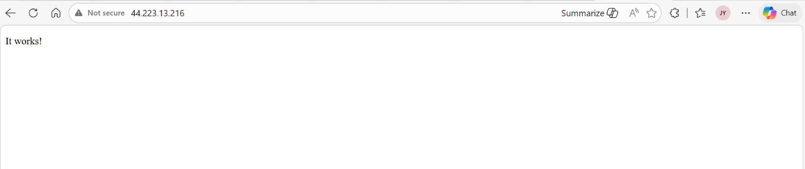

Conclusion
Through this implementation, I successfully configured a web server within a VPC and enabled secure internet access. Proper configuration of subnets, route tables, and security groups is essential to ensure both accessibility and security of cloud resources.


